IoT-Based Automatic Fish Feeder and Monitoring System

Table of Contents
Table of Contents

Project Overview 3
Project Description 3
Problem Statement 3
Objectives 3
General Objective 3
Scope and Limitations 4
Scope of the Study 4
Limitations of the Study 4
System Architecture 5
Architecture Description 5
Data Flow 6
Hardware Components 8
Software Components 8
Functional Requirements 8
Non-Functional Requirements 9
Database Design (Sample Fields) 10
System Operation Procedure 10
Gantt Chart 11
Expected Output 11
Development Period 12
Proof of System Functionality 13
Source Code 13

Project Overview

Project Description
The IoT-Based Automatic Fish Feeder and Pond Monitoring System is developed to automate fish feeding operations and monitor essential pond water conditions using Internet of Things (IoT) technology. The system improves feeding consistency and reduces manual effort while allowing users to monitor pond conditions remotely.
The proposed system integrates multiple water quality sensors and automated feeding components controlled by an ESP32 microcontroller. The sensing unit includes a DS18B20 temperature sensor used to measure water temperature, a PH-4502C pH sensor used to monitor water acidity, and a DFRobot turbidity sensor used to measure water clarity. A DS3231 Real-Time Clock (RTC) module provides accurate time reference to support scheduled feeding operations. These sensors continuously collect environmental data from the pond and transmit the readings to the ESP32 microcontroller for processing.
The ESP32 microcontroller serves as the central control unit of the system. It processes sensor readings, checks scheduled feeding times, and controls the feeding mechanism. The feeding mechanism uses a DS5160 servo motor connected to the fish feed container. The servo motor rotates according to programmed feeding schedules or manual commands from the web application. This mechanism allows controlled and consistent release of fish feed at specified intervals.
Collected sensor data and feeding activity records are transmitted through WiFi communication to a Firebase Firestore Realtime Database. The database stores water condition readings, feeding schedules, and feeding activity logs. A web-based monitoring dashboard retrieves stored data from the database and displays real-time information. Users access the dashboard through internet-connected devices to monitor pond conditions, view feeding history, and manually activate feeding when required.
The system operates using a solar-powered energy subsystem consisting of a solar panel, solar charge controller, rechargeable battery, and buck converter. The solar panel converts sunlight into electrical energy. The charge controller regulates voltage and protects the battery during charging. The battery stores electrical energy and supplies power to the ESP32 microcontroller, sensors, and servo motor. The buck converter reduces voltage to levels suitable for system components, allowing stable operation in outdoor environments.
The integration of automated feeding, water condition monitoring, wireless communication, and cloud-based data storage supports efficient fish pond management. The developed system produces a functional prototype suitable for small-scale freshwater fish pond environments. The system demonstrates the practical use of IoT technology in improving feeding accuracy, reducing feed waste, and maintaining stable pond monitoring operations.

Problem Statement
Fish feeding and pond monitoring in many small-scale aquaculture systems are still performed manually. Feeding schedules are often inconsistent, and important water parameters such as temperature, pH level, and turbidity are not continuously monitored. These conditions lead to inefficient feeding practices, increased labor effort, and delayed detection of unfavorable pond conditions that affect fish growth and health. This study aims to develop an IoT-Based Automatic Fish Feeder and Pond Monitoring System that automates feeding operations and monitors selected water quality parameters using sensors and cloud-based monitoring.
The study aims to address the following problems:
- Manual and inconsistent fish feeding schedules
Fish feeding depends on routine practice instead of controlled timing. This results in irregular feeding intervals and reduced feeding efficiency.
- Limited monitoring of pond water conditions
Temperature, pH level, and turbidity are not continuously monitored. Changes in water condition remain undetected until problems become visible.
- Dependence on manual observation
Farmers rely on visual inspection instead of sensor-based monitoring. This delays response to unfavorable water conditions.
- Increased labor requirements
Manual feeding and monitoring require daily physical presence. This increases workload and limits efficiency in pond management.
- Lack of stored monitoring and feeding records
Traditional methods do not store sensor readings or feeding logs. Without historical data, evaluating system performance becomes difficult.

Objectives General

Objective
To design, develop, and implement an IoT-Based Automatic Fish Feeder and Pond Monitoring System that automates fish feeding and monitors selected pond water conditions using sensor-based technology and cloud data storage to improve feeding consistency and pond management..
Specific Objectives
The study aims to achieve the following specific objectives:
- To design and develop an automated fish feeding mechanism using an ESP32 microcontroller and servo motor to release feed at scheduled time intervals.
- To integrate water quality sensors including temperature, pH, and turbidity sensors for real-time monitoring of pond conditions.
- To implement a Real-Time Clock (RTC) module to support accurate and consistent feeding schedules.
- To transmit collected sensor data using WiFi communication to a Firebase Firestore database for real-time monitoring and data storage.
- To develop a web-based dashboard that displays sensor readings, feeding schedules, and feeding activity logs for remote user access.
- To evaluate the performance of the system in maintaining consistent feeding schedules and improving monitoring of pond conditions.

Scope and Limitations
Scope of the Study
This study focuses on the design, development, and implementation of an IoT-Based Automatic Fish Feeder and Pond Monitoring System intended for small to medium-scale freshwater fish ponds. The system integrates automated feeding technology and selected environmental monitoring sensors to improve feeding consistency and support efficient pond management.
Specifically, the scope of the study includes the following:
- Development of a microcontroller-based automatic fish feeding mechanism using an ESP32 and servo motor to distribute feed at scheduled time intervals.
- Integration of environmental sensors including temperature, pH, and turbidity sensors to monitor pond conditions in real time.
- Implementation of a Real-Time Clock (RTC) module to maintain accurate feeding schedules.
- Programming of automated feeding schedules and manual feeding control through a web-based interface.
- Wireless transmission of collected data using WiFi communication to a Firebase Firestore database for remote monitoring and storage.
- Storage and visualization of environmental data and feeding logs through a web-based monitoring dashboard.
- Evaluation of the system’s performance in maintaining consistent feeding schedules and monitoring pond water conditions.

This study focuses on demonstrating the technical integration of automated feeding and real-time monitoring using IoT technology. The project develops a functional prototype suitable for experimental or small-scale fish pond environments. The system provides automated feeding and monitoring features but does not include advanced aquaculture automation systems or large-scale commercial deployment.

Limitations of the Study
Despite its intended functionality, the proposed system has several limitations that must be acknowledged. The limitations of the study include the following:
- The system depends on stable power supply from the solar panel and battery system. Insufficient sunlight or battery failure affects system operation and data transmission.
- The system relies on WiFi communication and internet connectivity for remote monitoring. Network interruptions delay data transmission and dashboard updates.The system monitors selected water quality parameters including temperature, pH level, and turbidity only. Other parameters such as dissolved oxygen, nitrate concentration, and salinity are not included in the system.

- The system automates feeding operations but does not perform automatic water treatment. Actions such as water replacement or aeration remain manual tasks performed by the user.
- The system prototype is designed for small to medium-scale pond environments. Performance in large commercial aquaculture systems is not evaluated.
- Sensor readings depend on proper calibration and environmental conditions. Sensor aging, improper calibration, and external disturbances affect measurement accuracy.

System Architecture

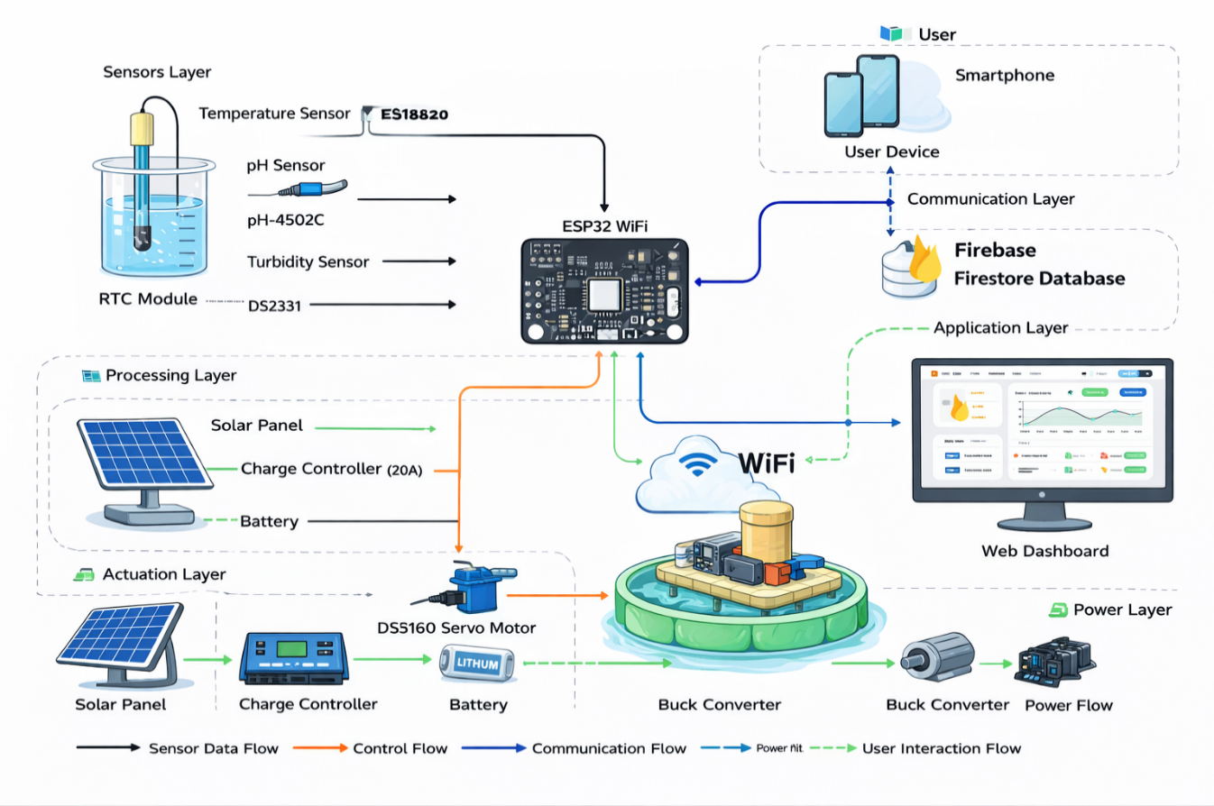

Figure 1: System Architecture

Architecture Description
The System Architecture Diagram illustrates the structure and interaction of the hardware and communication components used in the IoT-Based Automatic Fish Feeder and Pond Monitoring System. The diagram shows how electrical power, sensor data, processing operations, and communication processes work together to support automated feeding and remote monitoring.

The system begins with the power subsystem, which provides electrical energy required for continuous operation. A solar panel converts sunlight into electrical energy. The generated energy is transferred to the solar charge controller, which regulates the voltage and safely charges the 12V battery. The battery stores electrical energy and supplies power to the system during periods of low sunlight or nighttime operation. A buck converter is connected to the battery to reduce voltage to levels suitable for the ESP32 microcontroller and connected devices. This power configuration supports stable system operation in outdoor environments.

At the center of the system is the ESP32 microcontroller, which functions as the main processing unit. The ESP32 receives input data from multiple sensors and performs data processing and control operations. It also provides wireless communication through built-in WiFi, allowing the system to connect to cloud services for remote monitoring and data storage.

The system uses several environmental sensors to monitor water conditions. The DS18B20 temperature sensor measures the water temperature to track environmental changes. The PH-4502C pH sensor measures the acidity or alkalinity of the water. The DFRobot turbidity sensor measures water clarity by detecting suspended particles. These sensors send collected data to the ESP32 microcontroller for processing. A DS3231 Real-Time Clock (RTC) module is included to provide accurate timekeeping. The RTC supports scheduled feeding operations by maintaining precise time even during temporary power interruptions.

The feeding mechanism is controlled using a DS5160 servo motor. The servo motor operates as the main output device of the system. When the scheduled feeding time is reached, based on the time provided by the RTC module, the ESP32 sends a control signal to the servo motor. The servo motor rotates and releases fish feed from the feeding container. The servo motor can also be activated through manual commands sent from the monitoring system.

For communication, the ESP32 uses WiFi connectivity to transmit system data to the Firebase Realtime Database. Sensor readings, feeding schedules, and feeding activity logs are stored in the database. This allows the system to maintain updated records of environmental conditions and feeding operations.

The Firebase Realtime Database functions as the cloud storage component of the system. It stores real-time sensor data and feeding information and enables synchronization between the hardware system and the remote monitoring interface. The stored data can be accessed through a web-based application that allows users to monitor system performance and manage feeding operations.

Overall, the system architecture integrates renewable energy supply, sensor monitoring, wireless communication, and automated feeding control into a unified system. This structure supports reliable feeding operations, continuous monitoring of water conditions, and remote access to system information.

Data Flow

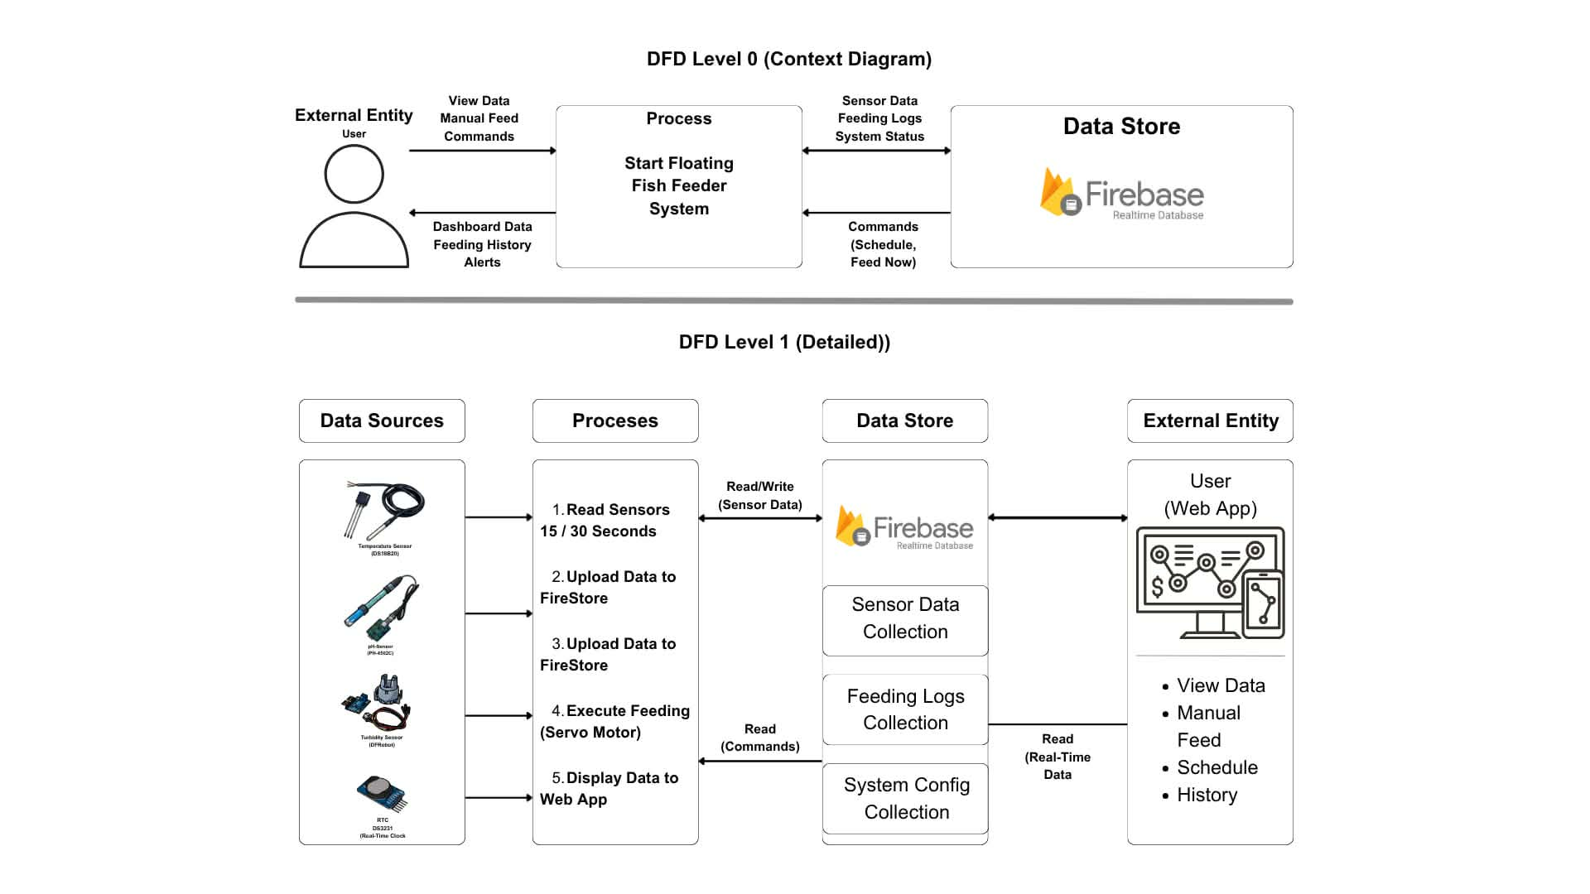

Figure 2: Data Flow
The Data Flow Diagram (DFD) illustrates how data moves through the IoT-Based Automatic Fish Feeder and Pond Monitoring System. The diagram presents two levels of detail: Level 0 (Context Diagram), which provides an overview of the system interaction, and Level 1 (Detailed Diagram), which describes the internal processes involved in system operation.

DFD Level 0 (Context Diagram)

The Level 0 Data Flow Diagram represents the system as a single main process interacting with external entities and a central data store. The main process is identified as the Floating Fish Feeder System, which manages sensor data collection, feeding operations, and communication with the database.

In this level, the User acts as the external entity who interacts with the system through a web application. The user sends input commands such as viewing system data and activating manual feeding operations. These commands are received by the Floating Fish Feeder System for execution.

The system exchanges data with the Firebase Realtime Database, which functions as the primary data store. The system sends collected sensor data, feeding logs, and system status information to the database. The database stores this information and returns configuration commands such as feeding schedules and manual feed requests.

The system also sends processed data back to the user in the form of dashboard information, feeding history, and alert notifications. This interaction allows the user to monitor system status and control feeding operations remotely.

The Level 0 diagram provides a high-level overview of the interaction between the user, the feeder system, and the database

DFD Level 1 (Detailed Diagram)

The Level 1 Data Flow Diagram provides a detailed representation of the internal processes that occur within the system. This level expands the main system into multiple processes that handle sensor data collection, data storage, feeding execution, and user interaction.

The process begins with the Data Sources, which consist of environmental sensors connected to the system. These sensors include the DS18B20 temperature sensor, PH-4502C pH sensor, DFRobot turbidity sensor, and DS3231 Real-Time Clock (RTC) module. These sensors collect environmental data and time information required for feeding operations.

The collected sensor data are processed in the Processes Section, where several internal functions take place. The system reads sensor values at regular intervals, with the temperature sensor being read every 15 seconds, and the pH and turbidity sensors being read every 30 seconds. After collecting sensor readings, the ESP32 processes the data and uploads the information to the Firebase Realtime Database.

The system then retrieves commands from the database, including feeding schedules and manual feeding instructions. When feeding conditions are met, the system activates the servo motor to release fish feed. This process ensures that feeding occurs at scheduled times or when manual commands are received from the user.

The Data Store Section represents the Firebase Realtime Database, which stores different categories of system data. These include sensor data collection, feeding logs collection, and system configuration data. The database continuously updates stored information and provides real-time synchronization between the system and the user interface.

The External Entity Section represents the user who interacts with the system through the web application. The user can view real-time sensor readings, monitor feeding history, set feeding schedules, and initiate manual feeding operations. The web application retrieves real-time data from the database and displays the information to the user.

Overall, the Level 1 diagram demonstrates how sensor data are collected, processed, stored, and used to control feeding operations. It also shows how users interact with the system through the web application to monitor and manage feeding activities.

.Hardware Components

Component | Description | Minimum Requirements | Recommended Requirements
Microcontroller | Main control unit with wireless communication support | ESP32 | ESP32 WiFi Module with stable power regulation
Temperature Sensor | Measures pond water temperature | DS18B20 | Waterproof DS18B20
pH Sensor | Measures acidity or alkalinity of pond water | PH-4502C pH Sensor Module | PH-4502C with calibrated pH probe
Turbidity Sensor | Measures water clarity and suspended particles | DFRobot Turbidity Sensor | Calibrated DFRobot Turbidity Sensor
RTC Module | Provides accurate timekeeping for scheduled feeding operations. | DS3231 RTC Module | DS3231 RTC with battery backup
Micro Servo Motor | Controls the automatic feeding mechanism by opening or rotating the feed container | DS5160 Servo Motor | High-torque DS5160 Metal Gear Servo
Solar Panel | Generates electrical energy from sunlight | 30W Solar Panel | 50W Solar Panel
Charge Controller | Regulates solar charging and protects battery | 10A Solar Charge Controller | 20A Solar Charge Controller
Battery | Stores electrical energy for system operation | 12V Rechargeable Battery | 12V LiFePO4 Battery
Buck Converter | Reduces voltage to suitable levels | DC-DC Buck Converter | High-efficiency Buck Converter
Feed Container | Stores fish feed and releases feed during operation | Plastic Feed Container | Weather-resistant Feed Container
Jumper Wires and Waterproof Cabling | Connects sensors, modules, and controller | Male-to-female jumper wires | Waterproof cables and sealed connectors
Enclosure and Structural Frame | Protects electronic components and supports the structure | Plastic enclosure | Waterproof enclosure with stainless steel frame
Table 1: Hardware Components

Software Components

Software | Purpose | Minimum Requirements | Recommended Requirements
Arduino IDE | Used for programming the ESP32 microcontroller | Arduino IDE | Arduino IDE with ESP32 Board Support
Firebase Firestore | Cloud database used to store sensor data, feeding logs, and commands | Firebase Realtime Database | Firebase Firestore
Web Application | Used to develop the monitoring dashboard interface for viewing pond conditions and system status | HTML, CSS, JavaScript | XUI Framework for responsive web dashboard
ESP32 Libraries | Provides communication and sensor control support | ESP32 Core Libraries | ESP32 Libraries with WiFi and Sensor Support
WiFi Communication | Handles wireless communication between ESP32 and database | ESP32 Built-in WiFi | Stable WiFi Network Connection
Table 2: Software Components

Functional Requirements
This section describes the core functional requirements of the IoT-Based Automatic Fish Feeder and Pond Monitoring System. These requirements define the operations the system must perform to monitor pond conditions, automate feeding, transmit data, and provide remote access to pond information.
- Sensor Data Acquisition
The system shall read temperature data from the DS18B20 sensor every 15 seconds. The system shall read pH and turbidity sensor data every 30 seconds.
- Data Processing
The system shall process collected sensor data using the ESP32 microcontroller. The system shall prepare sensor readings for transmission to the cloud database.
- Time-Based Feeding Control
The system shall use the DS3231 RTC module to maintain accurate feeding schedules. The system shall compare current time with stored feeding schedules.
- Manual Feeding Control
The system shall allow users to trigger manual feeding through the web application. The system shall activate the servo motor when a manual feed command is received.
- Automatic Feeding Execution
The system shall activate the servo motor when the scheduled feeding time is reached. The system shall rotate the servo motor to release fish feed.
- Data Transmission
The system shall transmit sensor data to the Firebase Realtime Database using WiFi communication..
- Data Retrieval
The system shall retrieve stored commands such as feeding schedules and manual feed instructions from the database.
- Web Dashboard Display
The system shall display real-time sensor readings through the web application dashboard. The system shall display feeding history and system status.
- Data Storage
The system shall display real-time sensor readings through the web application dashboard. The system shall display feeding history and system status.
10. System Monitoring
The system shall allow users to monitor system conditions through connected devices such as laptops or mobile phones.
Together, these functional requirements define the essential system operations from sensor-based data collection to automated feeding control and remote monitoring.

Non-Functional Requirements
This section describes the quality attributes that define how well the IoT-Based Automatic Fish Feeder and Pond Monitoring System performs its monitoring and control functions.
- Performance
The system maintains timely operation by reading temperature data every 15 seconds and pH and turbidity data every 30 seconds. Sensor readings are transmitted to the Firebase Realtime Database shortly after processing. Feeding actions occur immediately when scheduled time or manual commands are detected.
- Reliability
The system maintains stable operation using a solar power supply supported by battery storage. Sensor readings and feeding logs are stored in the database to prevent data loss. The RTC module ensures feeding schedules remain accurate even after temporary power interruptions.
- Security
The system restricts access to authorized users through controlled login access to the web application and database. Stored data remain protected from unauthorized modification or deletion.
- Usability
The system provides a user-friendly web dashboard that allows users to monitor environmental data and manage feeding operations. Users can view system status, set feeding schedules, and activate manual feeding through accessible interface controls. The displayed information is organized in clear and readable format.
- Security
The system restricts access to authorized users through controlled login access to the web application and database. Stored data remain protected from unauthorized modification or deletion.
- Environmental
The system operates in outdoor pond environments and uses protective enclosures to prevent damage from water exposure and environmental conditions. The system maintains stable operation under normal outdoor temperature and humidity levels.
These non-functional requirements ensure that the monitoring and feeding system operates efficiently, securely, and reliably in outdoor aquaculture environments.

Database Design (Sample Fields)

Field | Description
temperature | Stores the water temperature measured by the DS18B20 sensor.
pH_level | Stores the pH value measured by the PH-4502C pH sensor.
turbidity | Stores the water clarity value measured by the turbidity sensor
timestamp | Stores the exact date and time when sensor readings are recorded.

System Operation Procedure
This section describes the step-by-step procedure for operating the IoT-Based Automatic Fish Feeder and Pond Monitoring System. The process covers system startup, data collection, automated feeding, and remote monitoring.
Step 1: Power on the sensing and control unit
Power on the system
The system begins operation when electrical power is supplied from the solar panel and battery system. The solar panel generates electrical energy, which is regulated by the solar charge controller and stored in the battery. The buck converter reduces the battery voltage to suitable levels required by the ESP32 microcontroller and connected components. Once stable power is available, the ESP32 initializes system components and prepares for operation.
Step 2: Sensor data collection
Sensor data collection
The system collects environmental data from connected sensors at defined time intervals. The DS18B20 temperature sensor measures water temperature every 15 seconds. The PH-4502C pH sensor and DFRobot turbidity sensor measure pH level and water clarity every 30 seconds. These readings are automatically collected without manual input and sent to the ESP32 for processing
The system collects the following parameters:
- Temperature
- pH level
- Turbidity
Data collection runs automatically at defined intervals without manual input.
Step 3: Data processing by ESP32
Data processing by ESP32
The ESP32 receives sensor readings and performs data organization and validation. The controller checks if sensor values fall within acceptable operating ranges. The processed data are prepared for transmission and system control operations. The ESP32 also reads the current time from the DS3231 Real-Time Clock (RTC) module to verify feeding schedules.
Step 4: Automated Feeding Operating
Automated Feeding Operating
The system follows predefined feeding schedules stored in the database. The ESP32 compares the current time from the RTC module with stored feeding times. When the scheduled time is reached, the ESP32 sends a control signal to the servo motor. The DS5160 servo motor rotates and releases fish feed from the container. Feeding events are recorded for tracking and monitoring purposes.
The system also supports manual feeding through user commands sent from the web dashboard.

Step 5: Data transmission to cloud platform
Data Transmission to cloud platform
The ESP32 transmits sensor readings, feeding status, and system information through WiFi communication. The data are sent to the Firebase Realtime Database through internet connectivity. This transmission allows remote monitoring and synchronization between the hardware system and the cloud platform.

Step 6: Data Storage and logging
Data Storage and logging
The Firebase Realtime Database stores collected information for monitoring and historical tracking. The stored data include environmental readings, feeding activity logs, and timestamp records. These records support long-term monitoring, analysis, and system performance review.
The cloud database stores:
- Temperature readings
- pH readings
- Turbidity readings
- Feeding activity logs
- Timestamp records
Step 7: Monitoring through web dashboard
Monitoring through web dashboard
Users access the system through a web-based dashboard using internet-enabled devices such as laptops or mobile phones. The dashboard retrieves stored data from the Firebase Realtime Database and displays updated system information in real time.
- The dashboard displays:
- Real-time sensor readings
- Feeding status
- Feeding history
- System alerts and updates
This feature allows remote monitoring without requiring physical presence at the pond.
Step 8: User observation and decision-making
User observation and decision-making
The user reviews the data displayed on the web dashboard to monitor system conditions and feeding performance. Based on the displayed information, the user can make operational decisions such as initiating manual feeding or adjusting feeding schedules when necessary. The system continues repeating the monitoring and feeding cycle throughout operation.

Gantt Chart (Kenji Yonaha)

Task / Phase |  | Week 1 | 2 | 3 | 4 | 5 | 6 | 7 | 8
Project Planning & Proposal |  | ███ | ███
Requirements Analysis |  |  | ███ | ███
System Architecture Design |  |  |  | ███
Hardware Setup & Wiring
Sensor Integration (Temp, pH, etc.)
Firmware Development (ESP32)
Feeding Mechanism Development (Servo)
Communication Setup (Lora/Wifi)
Cloud Database Setup (Firebase)
Web Dashboard Development
System Integration
Testing & Debugging
Documentation Writing
Final Evaluation & Submission

Gantt Chart (Alessandra Rivano)

Task / Phase |  | Week 1 | 2 | 3 | 4 | 5 | 6 | 7 | 8
Project Planning & Proposal |  | ███ | ███
Requirements Analysis |  |  | ███ | ███
System Architecture Design |  |  |  | ███
Hardware Setup & Wiring
Sensor Integration (Temp, pH, etc.)
Firmware Development (ESP32)
Feeding Mechanism Development (Servo)
Communication Setup (Lora/Wifi)
Cloud Database Setup (Firebase)
Web Dashboard Development
System Integration
Testing & Debugging

Gantt Chart (Lady Jane Laurente)

Task / Phase |  | Week 1 | 2 | 3 | 4 | 5 | 6 | 7 | 8
Project Planning & Proposal |  | ███ | ███
Requirements Analysis |  |  | ███ | ███
System Architecture Design
Hardware Setup & Wiring
Sensor Integration (Temp, pH, etc.)
Firmware Development (ESP32)
Feeding Mechanism Development (Servo)
Communication Setup (Lora/Wifi)
Cloud Database Setup (Firebase)
Web Dashboard Development
System Integration
Testing & Debugging

Gantt Chart (Brian Jalos)

Task / Phase |  | Week 1 | 2 | 3 | 4 | 5 | 6 | 7 | 8
Project Planning & Proposal |  | ███ | ███
Requirements Analysis |  |  | ███ | ███
System Architecture Design
Hardware Setup & Wiring
Sensor Integration (Temp, pH, etc.)
Firmware Development (ESP32)
Feeding Mechanism Development (Servo)
Communication Setup (Lora/Wifi)
Cloud Database Setup (Firebase)
Web Dashboard Development
System Integration
Testing & Debugging
Documentation Writing
Final Evaluation & Submission

Gantt Chart (Redden Russel Ortega)

Task / Phase |  | Week 1 | 2 | 3 | 4 | 5 | 6 | 7 | 8
Project Planning & Proposal |  | ███ | ███
Requirements Analysis |  |  | ███ | ███
System Architecture Design
Hardware Setup & Wiring
Sensor Integration (Temp, pH, etc.)
Firmware Development (ESP32)
Feeding Mechanism Development (Servo)
Communication Setup (Lora/Wifi)
Cloud Database Setup (Firebase)
Web Dashboard Development
System Integration
Testing & Debugging
Documentation Writing
Final Evaluation & Submission

Expected Output
The expected outputs of the IoT-Based Automatic Fish Feeder and Pond Monitoring System include automated monitoring of water conditions, controlled feeding operations, and real-time data access through a web-based dashboard. The system produces reliable sensor readings, feeding records, and a functional prototype capable of supporting efficient pond monitoring and feeding management.
- Automated Water Quality Monitoring
The system automatically collects pond data using integrated sensors. Each recorded entry includes temperature, pH level, turbidity, and timestamp information. This automated process reduces the need for manual monitoring and supports continuous observation of water conditions.
- Accurate and Reliable Sensor Data
The ESP32 microcontroller processes and validates sensor readings before transmission to the database. This ensures reliable and consistent monitoring of pond conditions. The system maintains organized data records for temperature, pH level, and turbidity readings.
- Automated Fish Feeding Mechanism
The system controls a servo motor to dispense fish feed at scheduled intervals using time reference from the RTC module. Feeding operations occur consistently and release controlled feed portions, which helps reduce feed wastage and improve feeding accuracy.
- Real-Time Pond Condition Monitoring
Water quality data are transmitted through WiFi communication and displayed in real time through the web-based dashboard. Users can monitor pond conditions without delay and observe current sensor readings from remote locations.
- Centralized Cloud Database
All sensor readings and feeding logs are stored in the Firebase Realtime Database. The database supports storage, retrieval, and synchronization of data between the hardware system and the web application.
- Feeding Activity Monitoring
The system records feeding events, including feeding time and operation status. These stored records allow users to review feeding schedules and monitor feeding performance through the web dashboard.
- Web-Based Monitoring Dashboard
The system provides a web interface that displays real-time sensor readings, feeding schedules, and feeding history records. Authorized users can access the dashboard using internet-enabled devices to monitor and control system operations remotely.
- Functional IoT-Based Fish Feeder Prototype
The final output is a fully assembled and operational prototype that integrates sensors, ESP32 microcontroller, WiFi communication, servo motor feeding mechanism, and cloud database connectivity. The prototype demonstrates automated feeding and continuous monitoring under normal operating conditions.

Development Period
The development period refers to the actual time span during which the system was designed, built, programmed, tested, and finalized. For this project, the development period covers eight (8) weeks, starting from project planning up to final evaluation and documentation.
During this period, all major activities—including hardware assembly, sensor integration, ESP32 firmware development, feeding mechanism development, communication setup, cloud database configuration, web dashboard development, and system testing—were completed according to the approved Gantt chart. Documenting the development period demonstrates that the project followed a systematic and time-bound development process, rather than being completed abruptly or without proper planning.
Pictures During Development (Documentation Evidence)
Pictures serve as visual proof of system development and implementation. These images should be captured during actual development, not only after project completion.

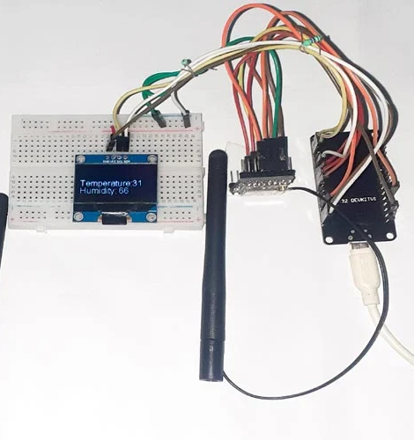
Figure 3: Development Period

Recommended Development Photos

Hardware Assembly Photos
Images showing the ESP32, sensors (temperature, pH, turbidity, ammonia), servo motor, motor driver, wiring connections, and power supply during setup and testing.

Programming and Configuration Photos
Screenshots of the firmware code in Arduino IDE, system configuration, and serial monitor output while reading sensor data and controlling the feeding mechanism.

Sensor Data Monitoring
Photos showing actual sensor readings displayed on the serial monitor or LCD (if applicable). This proves that the system is collecting real-time pond data.

Feeding Mechanism Operating
Images showing the servo motor activating and dispensing fish feed during scheduled operation.

Web Dashboard Screenshots

Screenshots of the web dashboard displaying:

Real-time water quality data

Feeding status

Historical logs

Testing and Debugging Activities
Photos showing system testing, calibration of sensors, and verification of data transmission and feeding operations.

Proof of System Functionality
To strengthen project credibility, include the following proofs:
- Timestamped Sensor Data Logs
  - Screenshots of stored data showing temperature, pH, turbidity, ammonia, and timestamp
  - Demonstrates real-time monitoring and data logging
- Feeding Activity Logs
  - Records showing feeding time and operation status
  - Confirms automated feeding functionality
- Source Code and File Structure
  - Excerpts of ESP32 firmware and web dashboard code
  - Shows system implementation and originality
- Versioned Development Timeline
  - Saved versions or commits of code throughout development
  - Confirms step-by-step system progress
- Test Results and Outputs
  - Screenshots or tables showing successful sensor readings, data transmission, and feeding execution
  - Confirms that system requirements were achieved

Source Code

Arduino-Automatic-Fish-Feeder/IOT Project Code.txt at main · anitejM/Arduino-Automatic-Fish-Feeder

